3)

1. Outputs to 3, we can see that in the filter bank, it reduces the image with a -45-degree angle.
2. Outputs to 6, we can see that in the filter bank, it reduces the image with a 45-degree angle.
3. Outputs to 1, in the filter bank it is filtering the image by horizontal nature.
4. Outputs to 2, in the filter bank it is filtering the image by vertical nature.
5. Outputs to 5, as the filter bank has a nature similar to Laplacian mask that highlights edges.
6. Outputs to 4, as it does little to no effect to the image.

4)

1. The gaussian low-pass filter was used to allow high frequencies detected as artifacts (short-term fluctuations) to be removed in the image which tries to saturate the white part at the center of the ring finger to become invisible to the eye but the edge values are still strongly intact.

Then the gaussian high-pass filter is used to outline the edges in the image such as the bones, but since the white part at the center of the ring finger is still present very strongly in the image, due to the nature of the high-pass filter (removing low frequencies and remove ringing effect) it will get highlighted and shown brighter than the rest of the grey area due to its really strong presence.

1. In theory, the presence of the white spot is strong as it has a larger coverage than the average artifact such as salt and pepper noises, and more importantly mathematically it should produce the same result since it is a linear transformation, so no it shouldn’t matter if the process is reversed.

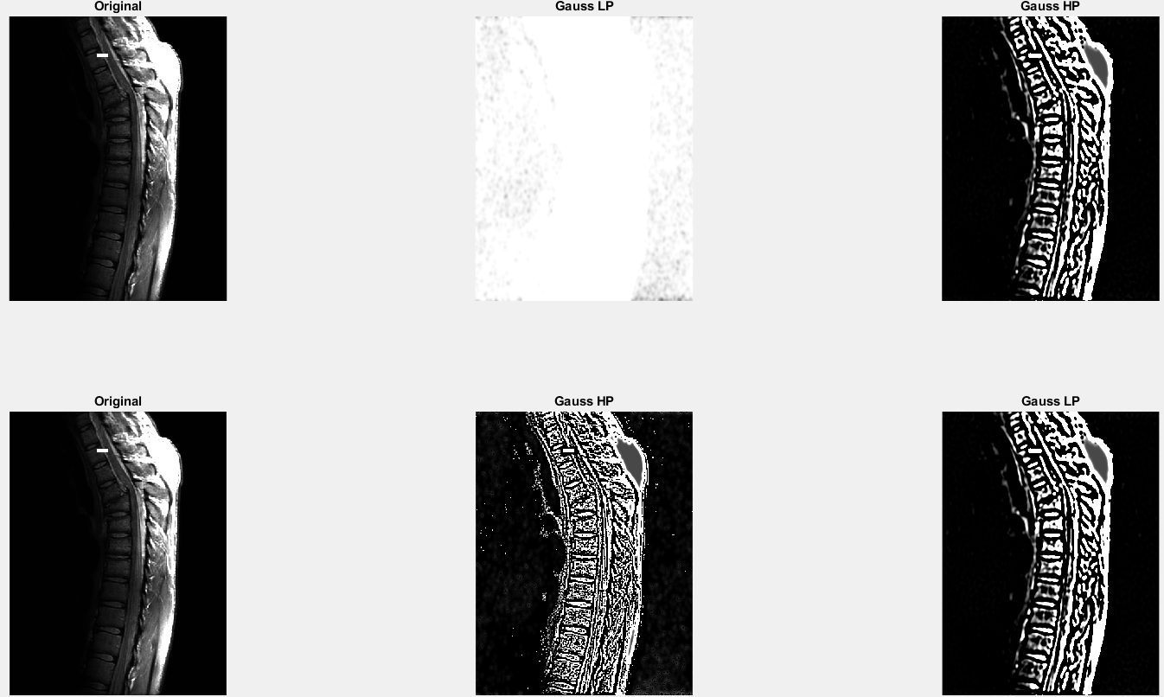In the sample image below to test the theory in a) and b), I added a white square similar to the white part of the center of the ring finger in the question, and it showed a strong presence in the resulting image.